Technical Datasheet Busbar Sensor kit
System Overview:
The Busbar Sensor Kit is a comprehensive, standalone temperature monitoring solution designed for critical power distribution and switchgear systems. It combines distributed multi-point thermal sensing with intelligent local alerting and upstream system integration.

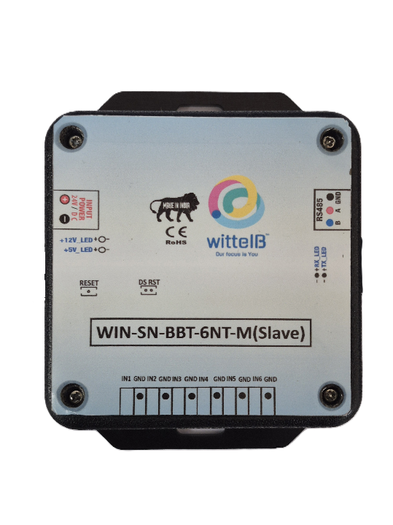
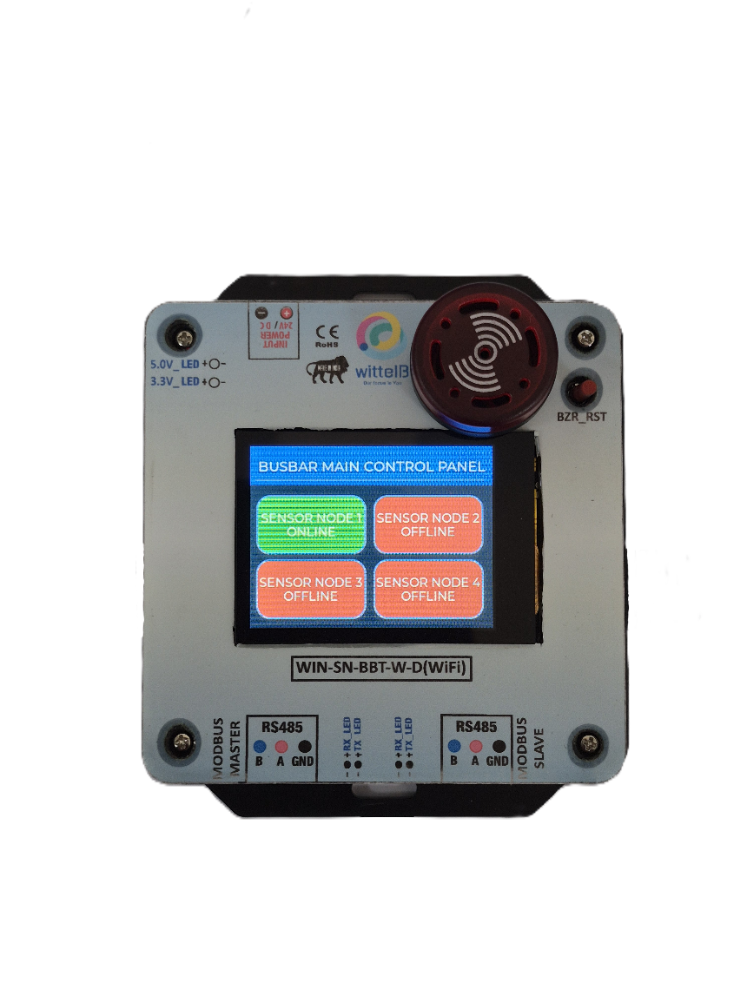
Busbar Sensor Kit:-
I/p SPLY
I/p SPLY
Modbus
Slave
Modbus
Slave
Modbus
Master
NT1 | NT2 | NT3 | NT4 | NT5 | NT6
Sensors I/p
Buzzer & LED
Buzzer Reset

System Architecture & Components:
The complete kit operates on a robust RS485 network and consists of the following hardware.
- 1 of Master Controller Unit: The central hub of the system. It acts as a Modbus Master to continuously poll data from the connected sensor nodes, while simultaneously functioning as a Modbus Slave to pass aggregated data upstream to a SCADA system, PLC, or BMS.
- 1 – 4 of 6-Channel NTC Sensor Nodes: The kit includes four distributed 6-channel NTC expansion modules, providing a total of 6 - 24 independent temperature monitoring points. These sturdy, low-power modules can communicate with the master over distances up to 200 meters without a repeater.
- However, it’s recommended that the Master and Slave be contained in the same electrical Panel so that same Input Power and ground reference is used across Master and Slave devices.
Hardware Protection & Core Features:
The system is housed in industrial DIN rail-mountable casings with exposed pluggable connectors for easy installation. It is designed with multiple layers of protection, including Optically isolated NTC sensor inputs to protect against noise and ground loops, and resettable fuses to safeguard against reverse polarity. The Master Unit also features a built-in interactive display and audio/visual alarms for immediate on-site status awareness.
Specifications
NTCs :–
PART NUMBER |  | 
Sensing Element | Thermistor NTC | Thermistor NTC
No-load resistance at 25°C | 10 000 Ω | 10 000 Ω
Tolerances at 25°C | ± 1% | ± 1%
Beta(25/85) Constant | 3 435K ±1% | 3 977K ±1%
Operating temperature range | -40°C - 105°C | -40°C - 125°C
Test Voltage | 1500V DC | 500V DC
RoHS Compatible | YES | YES

NTC Node :–
NTC 2x 6-Pin 3.81 mm pitch pluggable screw terminals (providing 6 NTC channels total for each Node)
Dimensions 85 mm L x 108 mm W x 35.5 mm H
Power 2-Pin 3.81 mm pitch pluggable Typical – 12/24V DC
Operating Temperature 0 – 60° C (32 ~ 140°F)
Storage Temperature -20 - 70° C (-4 ~ 158°F)

Storage Humidity 5 ~ 95 % RH, non – Condensing

Certifications
Master Unit :–
NTC 2x 3-Pin 3.81 mm pitch pluggable terminals (Modbus master & Slave).
Dimensions 98.5 mm L x 122.7 mm W x 35.5 mm H
Power 2-Pin 3.81 mm pitch pluggable Typical – 12/24V DC
Operating Temperature 0 – 60° C (32 ~ 140°F)
Storage Temperature -20 - 70° C (-4 ~ 158°F)

Storage Humidity 5 ~ 95 % RH, non – Condensing

Certifications

Note: -
For MODBUS communications, a shielded and twisted pair cable is used. One example of such cable is Belden 3105A.
Recommended Cable Electrical Characteristics: -
22 AWG Cable Shielded and twisted pair should be used.
Tinned Copper Recommended
Nominal Conductor DCR 14.7 ohm / 1000 ft
Nominal Capacitance 11 pf / feet (conductor to conductor)
High Frequency Non-Insertion Loss 0.5db / 100ft

Additional Features :-
All inputs and communication ports isolated
Input power reverse polarity safety
ESD Safety IEC 61000-4-2, ± 30KV contact, ± 30KV air
EFT IEC 61000-4-4, 50A (5/50ms)
750V isolation.
CRC Error check.
No configuration needed on the board

Local HMI Dashboard & Alarm Management:
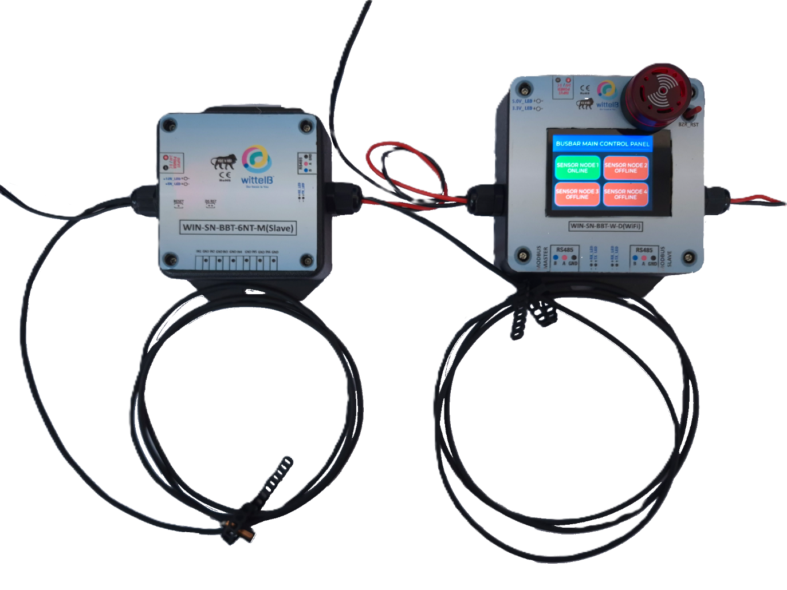
The Master Controller Unit features an intuitive, interactive touch display paired with robust physical alarm mechanisms to ensure operators have immediate, actionable awareness of the busbar's thermal health.
Interactive Touchscreen Dashboard:
- High-Level Overview: The home screen acts as the "Main Control Panel," providing a quick-glance status of all 4 distributed Sensor Nodes (SN1 through SN4), clearly indicating whether each node is currently Online or Offline.
- Detailed Channel View: Tapping on any active Sensor Node block (e.g., SN1) drills down into that specific module, displaying the real-time temperature readings for all 6 of its connected NTC thermistors.
- Label Customization: To make monitoring as intuitive as possible, users can rename the default "Temp x" channel labels to reflect their exact physical locations (for example, renaming "Temp 1" to "Main/ Breaker/ Phase R, etc.").

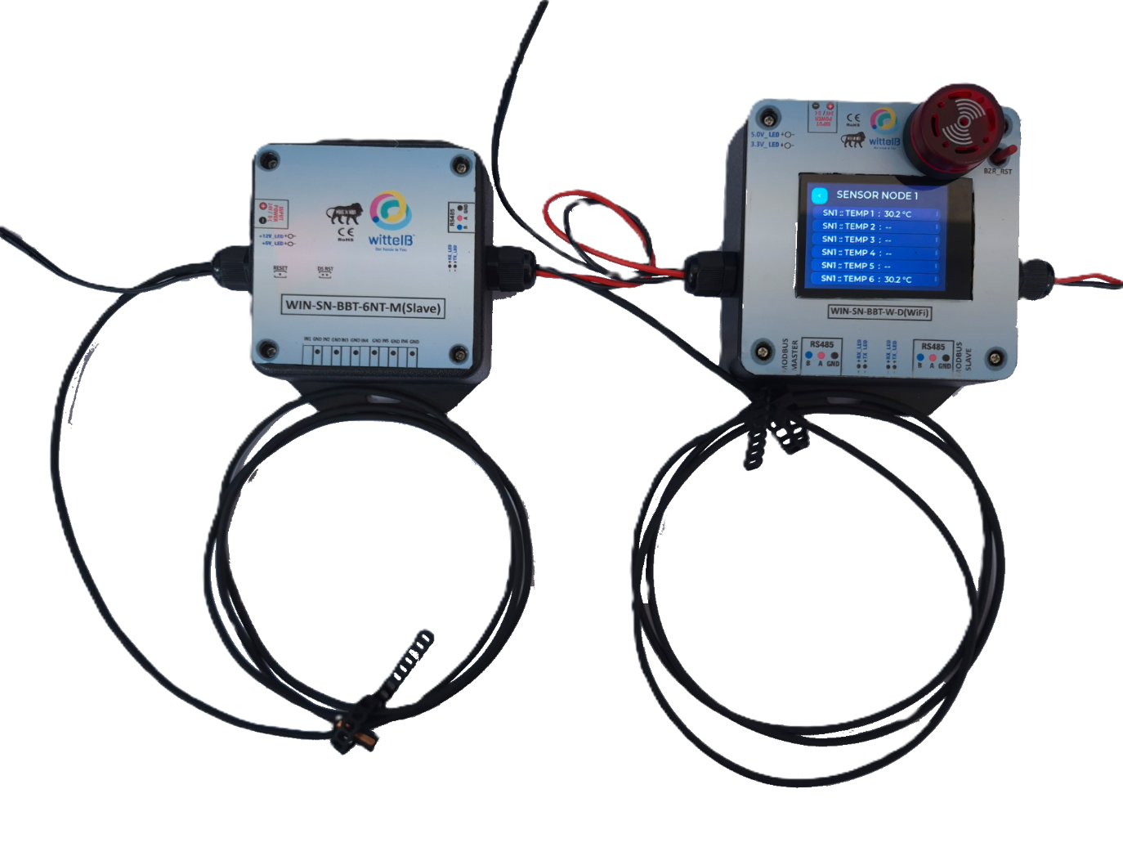
Critical Alarm & Acknowledgment System:
- Multi-Tier Alerts: If any individual NTC sensor detects a temperature that exceeds its safe threshold, the system immediately goes into an alarm state. The specific reading on the display will turn red, and the prominent physical buzzer and LED module on top of the unit will activate to alert nearby personnel.
- Alarm Acknowledgment (Snooze): A physical reset button (BZR_RST) is located directly next to the buzzer. Pressing this acknowledges the fault, temporarily silencing the buzzer and turning off the LED for a predefined "snooze" period (e.g., 5 to 10 minutes) while the issue is investigated.
- Safety Re-trigger Logic: If the temperature remains above the critical threshold after the snooze timer expires, the audio and visual alarms will automatically reactivate, ensuring that sustained thermal hazards are never forgotten or ignored.
Flexible System Configuration:
The system is designed for both local and remote management. Users can fully customize the critical temperature thresholds and alarm parameters directly through the local touch display, or program them remotely via the upstream Modbus Master connection.
Integrated Wi-Fi Configuration & IoT Telemetry:
- Unlocking advanced flexibility for field technicians, the Master Unit is equipped with an integrated Wi-Fi module to simplify initial deployment and ongoing maintenance. By connecting wirelessly via a smart device operators can rapidly access the system's configuration interface without the need to tether themselves with physical serial cables. This local wireless accessibility allows for effortless sensor node naming, threshold customization, and rapid diagnostics right from the factory floor.
- Beyond local configuration, this Wi-Fi capability transforms the Busbar Sensor Kit into a fully integrated IoT device capable of powerful remote telemetry. Utilizing lightweight MQTT protocols over the wireless network, the Master Unit can securely publish real-time temperature data and critical alarm states directly to cloud-based dashboards or remote facility management platforms. This seamless IoT integration ensures that off-site engineers maintain absolute visibility over the electrical infrastructure's thermal health, eliminating the need for complex, hardwired intermediate gateways.

Contact us: -
Augmatic Technologies Pvt. Ltd.,
Plot no 6, Shah Industrial Estate II,
Kotambi,
Vadodara – 391510.
Email – Sales@wittelb.com
Support: support@wittelb.raiseaticket.com / +91 94038 92805

